|  |  |  |  |  |  |  |  |  |  |
| --- | --- | --- | --- | --- | --- | --- | --- | --- | --- |
|  |  |  | **CL117** | | |  |  | **LAB 04** |  |
|  | I |  |  |  |  |  |  |  |
|  | **INTRODUCTION** | | | | |  |
|  |  |  | **Introduction to Operating Systems** |  |
|  |  |  |  |  |  |  |  |  |
|  | **TO ICT** | | | | |  |
|  |  |  |  |  |
|  | | | | | | |  | |  |
| **NATIONAL UNIVERSITY OF COMPUTER AND EMERGING SCIENCES** | | | | | | | | |  |

**Text editor in linux :**

Like notepad in windows linux has various text editors such as ( Vim, nano, vi etc) they are used to write bash codes or just to create simple text files.

We are going to use vim in this example.  
  
To install vim use the command



Now to create a file you can use the command : vim <yourfilename>

**Example :**



Here you can now write text to your file by pressing “I”

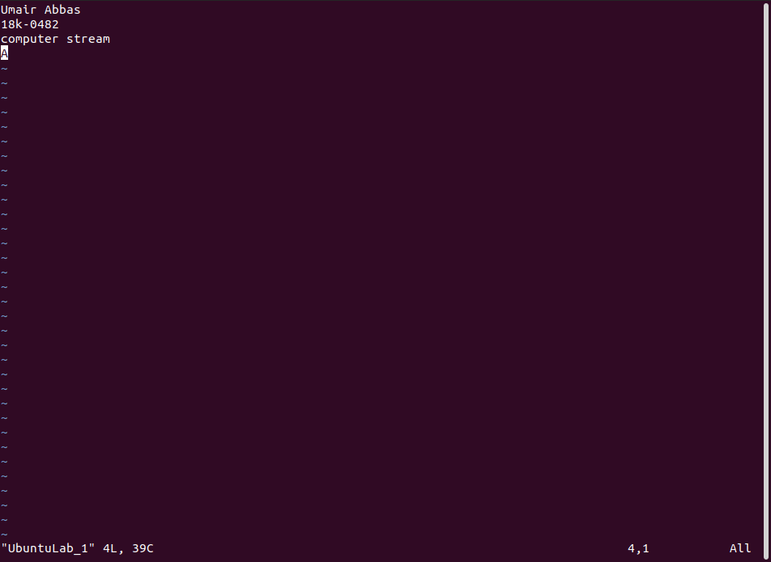

You can exit vim by pressing “Esc” then type “**:x!**” this will save your file and exit. And “**:q!”**  to quit without saving.

**Creating and removing Directories :**

Each operating system allows us to easily manage our files and folders. In linux terminal

* We can switch between the directories using “**cd <Your Directory>**”.
* We can list the files in some directory using “**ls < Your Directory >**”.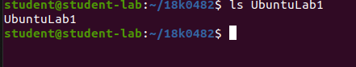
* We can create a directory using “**mkdir <Name of Directory>”.**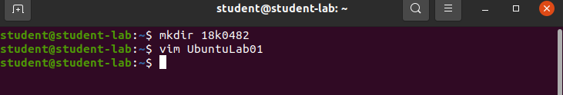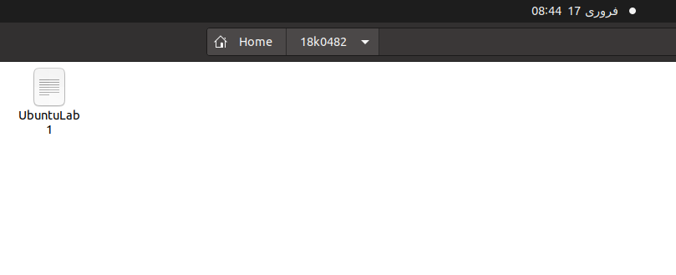
* And finally we can remove it using “**rmdir <Name of Directory>**”.

**Files in linux :**

* You can create files in linux using “**touch <filename>**”. Or “**touch multiple file names**”.

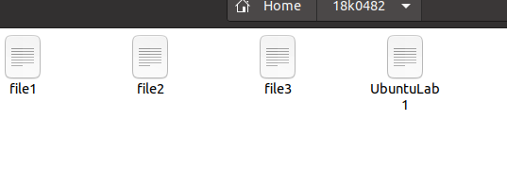

* You can remove files using “**rm <filename>**”.
* You can read your files using “**cat <filename>**” or “**cat multiple files**”. 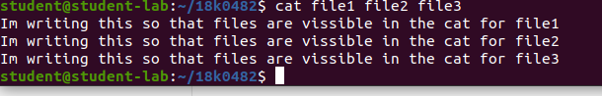
* To merge content of multiple files you can use “**cat file1 file2 >> mergedfile**”

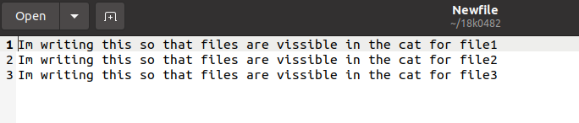

**Permissions in linux**

**Now these files can have different permission levels such as being read-only for certain users but you can modify permissions in linux and change the owner of files as well.**

**Changing permissions:**

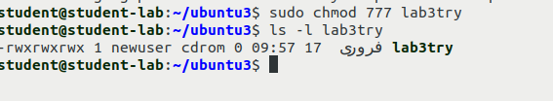

**Changing owner:**

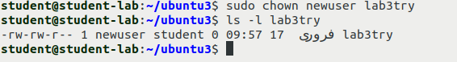

**Creating and managing Users in Linux**

To create a user in linux we use “**adduser <username>**” but since creating a user need administrative privileges we use it with “**sudo**”.

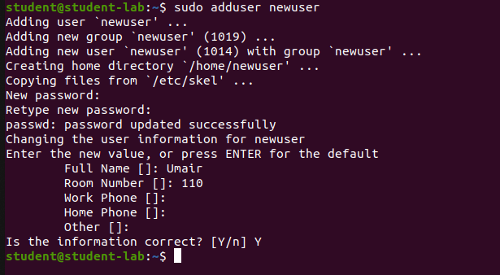

**Changing Password:**

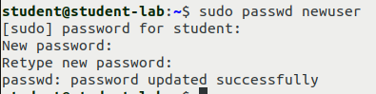

**Changing User:**

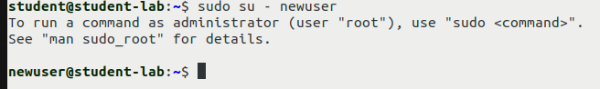

**Tasks :**

1. Create a new user with your roll-number and add a password to it.
2. Switch to the user that you just created and create a new directory with your name. eg: mkdir umairabbas. And enter that directory
3. Create 3 files using touch named About me, My goals, Concepts of OS
4. Write 5 appropriate lines in those files using vim.
5. Read those files in terminal using cat.
6. Merge those files in a file named “Complete_info” and read it on the terminal.
7. Remove Each file and then remove the directory.

**Note : Each of the tasks should be documented on a word file with input and screenshots of output.**

**END**